**Assignment 1: Project Ideation**

**Name: Ida Bagus Ketut Yoghantara**

1. Understand the overview of the Community Portal from Project Mentor.

|  |  |  |
| --- | --- | --- |
| No | Questions | Answers |
| 1 | Can this community portal help you to find a job? | Yes, we can find and search any jobs we want and also know what the job need |
| 2 | What colours do you want to see in any website that you will visit? | I like Blue-Yellow or Red-Green colour contrast, they are good combination |
| 3 | What device do you usually use when browsing internet? | I’m mostly using my own computer |
| 4 | How many hours do you usually browsing in internet a day? | Around 2 to 4 hours a day |
| 5 | What do you prefer, simple or interactive website? | I prefer simple looking website but also interactive |
| 6 | What would you do if you find a broken website? | I immediately close that website |

1. Persona
   1. List the different personas who will be using the Community Portal, with brief description of each of the personas.

|  |  |  |
| --- | --- | --- |
| No | Persona | Brief Description |
| 1 | Bobi | Bobi is a 35 years old Math Teacher who regularly using his own laptop to browsing on the internet. He want to switching career to be a Software Engineer |
| 2 | Asep | Asep is a 24 years old fresh graduate from Computer Science Major. He want to work in an IT Company. |

* 1. Create a Personas profile with Demographics, Behaviours & Beliefs, Characteristics & Goals for 2 Personas defined.

|  |  |
| --- | --- |
| Persona (1): | Bobi |
| Demographics: | 35, Male, Indonesian, Employed |
| Behaviours and Beliefs: | Likes to solve puzzle If you don't stand for something you will fall for anything. |
| Characteristics: | Optimistic, sporty, diligent, active |
| Goals: | To be a Software Engineer |

|  |  |
| --- | --- |
| Persona (2): | Asep |
| Demographics: | 24, Male, Indonesian, Unemployed |
| Behaviours and Beliefs: | Reading books Don't be afraid of your fears. |
| Characteristics: | Diligent, active, easy going |
| Goals: | Being a good programmer |

1. Conduct Ideation for the Project Scenario and come up with 2 Ideas to meet the Project Scenario

Scenario Name: Login Page

|  |  |
| --- | --- |
| No | Ideas |
| 1 | User go to the homepage user clicking the login button and they will be directed to login page  user enter username and password  user clicking the login button  if the entered username and password is correct then user will be directed again to homepage |
| 2 | User go to the homepage  If the user don’t have login saved in the website then pop up for login will appear  user enter username and password and press the login button  if username and password is correct then login popup will disappear |
|  |  |

1. Create Scenario & Storyboard for one of the Scenarios

Register

Login

**Click login button**

Login Page

Home Page

Sign In

**Input username**

Username

**Directed to homepage**

**Input password**

Password

Sign In

Login

Username

Alex123

Password

*************

Login

**Click login button**

1. Use Axure to Create a Wireframe Prototype for 1 Scenario

Scenario Name: Login Scenario

|  |  |
| --- | --- |
| Wireframe pages | Specifications (Widget Table) |
| Login Page | 1. Header (Login) Heading to know it’s for login 2. Email/Username Text box for user to type their email or username 3. Password Text box for user to type their password 4. Forgot password If user forgot their password they can clicks this link to go to the recovery page 5. Login Button For login after finish typing valid username and password 6. Login with google Another choice to login with google 7. Image on the right side of the login section, it will be an image for beautify the page |

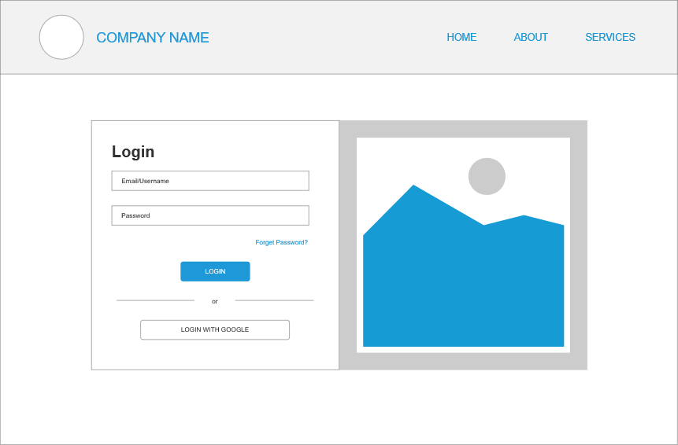

**Zip File**



1. Plan the Implementation for the Project Scenario

|  |  |
| --- | --- |
| Priorities | Scenarios |
| Top | 1. Navigation bar and search bar  2. Login page  3. Forgot Password |
| Medium | 1. Seeing other user profile  2. Chat or comment system between user  3. Job category  4. Autocomplete search bar |
| Nice to have | 1. Like user profile  2. Up vote / down vote other user comments |